

User Manual

Eilia Keyhanee

Contents

Client 2

Login Screen: 2

Settings Screen: 2

Home Screen: 3

Patients List Screen: 3

New Patient Screen: 4

Patient Details Screen: 4

New Visit: 5

Visit Details Screen: 5

# Client

## Login Screen:

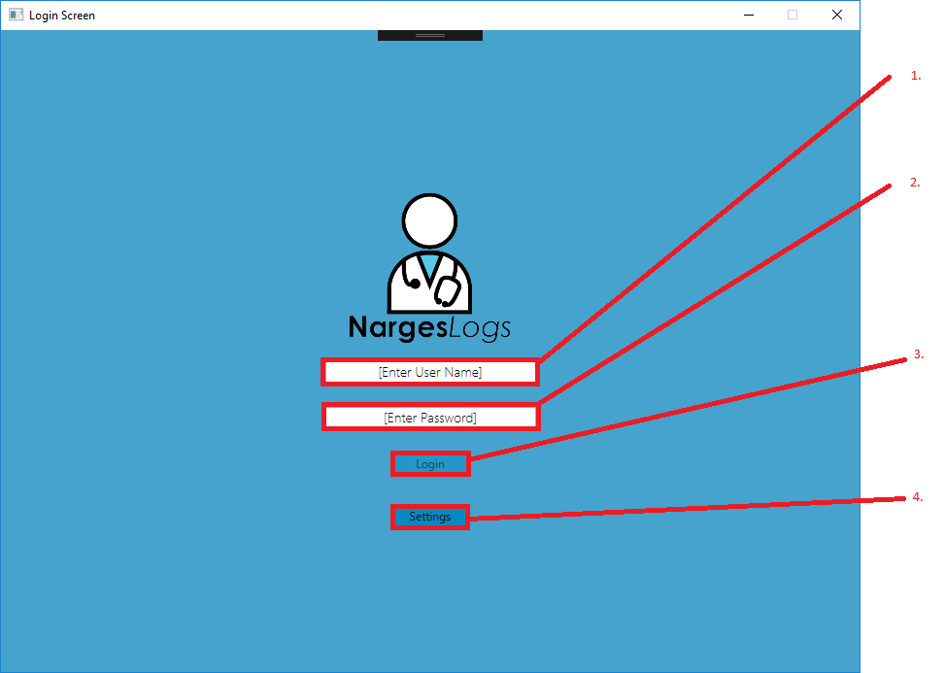

1. Username field: Enter your valid username here.
2. Password field: Enter your corresponding valid password here.
3. Login button: Click to log into the application. This button will remain disabled until a username and password is entered.
4. Settings: Click to open the settings menu.

## Settings Screen:

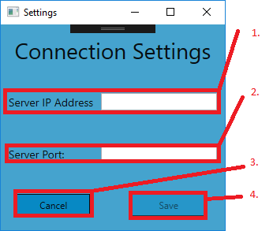

1. IP Address field: Enter the IP address of the server you would like to connect to (e.g. 216.3.128.12); you can get this address by contacting the host of the server. Alternatively, you may connect to a locally hosted server by entering ‘localhost’ into the field (this is the default value of this field).
2. Port field: Enter the port of the application, this is almost always ‘3214’ (this is the default value of this field), However future or modified versions of this application may use a different port.
3. Cancel button: Cancels all changes and returns to the login screen.
4. Save button: Saves the connection settings and returns to the login screen. This button remains disabled until an IP address and Port are entered.

## Home Screen:

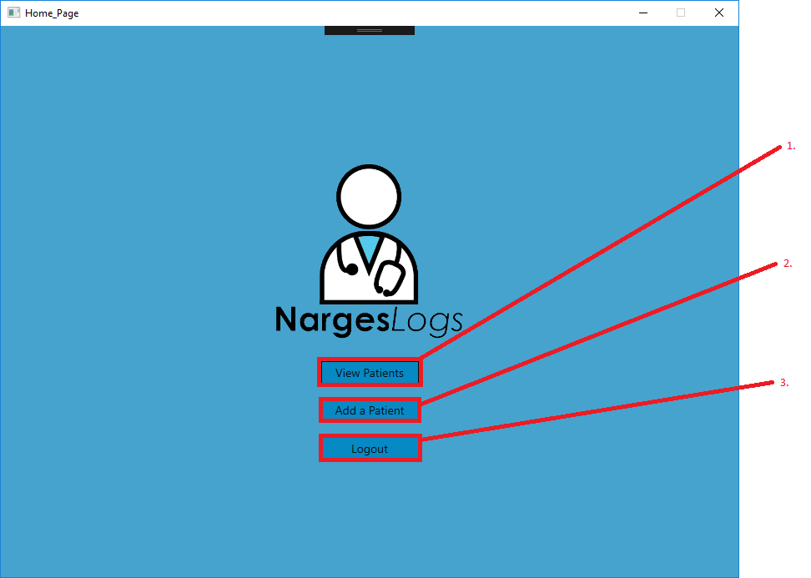

1. View Patients button: Opens the Patients List Screen where a list of existing patients can be viewed.
2. Add a Patients button: Opens the Patient Details page where a new patient can be added.
3. Logout button: Disconnects from the server and returns to the Login Screen.

## Patients List Screen:

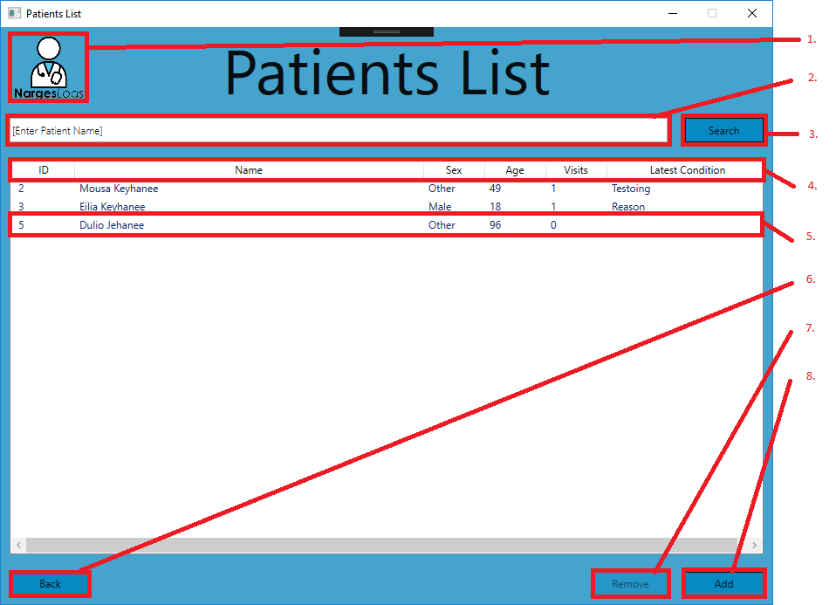

1. Logo: Clicking the logo will return the application to the home page.
2. Search field: Enter a name or parts of a name into this field before clicking search. Clear this field and click search to revert a search.
3. Search button: Clears the patients field and only displays patients with the search field contents as a part of their full name.
4. Headers: Click on one of these headers to sort the displayed patients in order of the specified category. Click again to reverse the sort.
5. Patient list item: Double click on a patient list item to view the patient in detail.
6. Back button: Return to the home screen.
7. Remove button: Remove the selected patient. This button will remain disabled until a patient is selected.
8. Add button: Enter the Patient Details page where a new patient can be added.

## New Patient Screen:

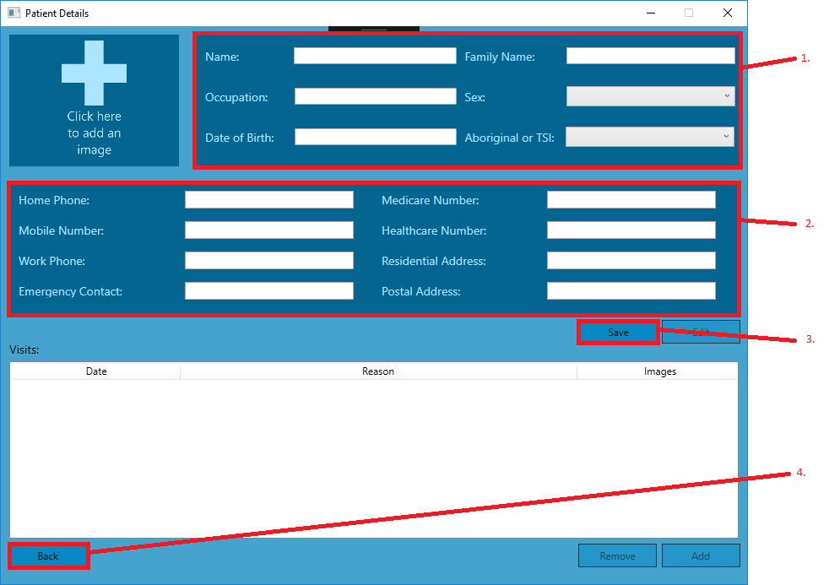

1. Primary Information fields: Enter the basic information of the new patient.
2. Enter the details of the patient. Any fields that cannot be entered should have ‘N/A’ or some equivalent entered instead.
3. Save button: Uploads the entered information to the server and exits edit mode, effectively making the window a Patient Details Window (Please view the Patient Details section for more information about this window after the save button has been clicked)
4. Back button: exits the menu and returns to the Patients list page. Erases any unsaved changes.

## Patient Details Screen:

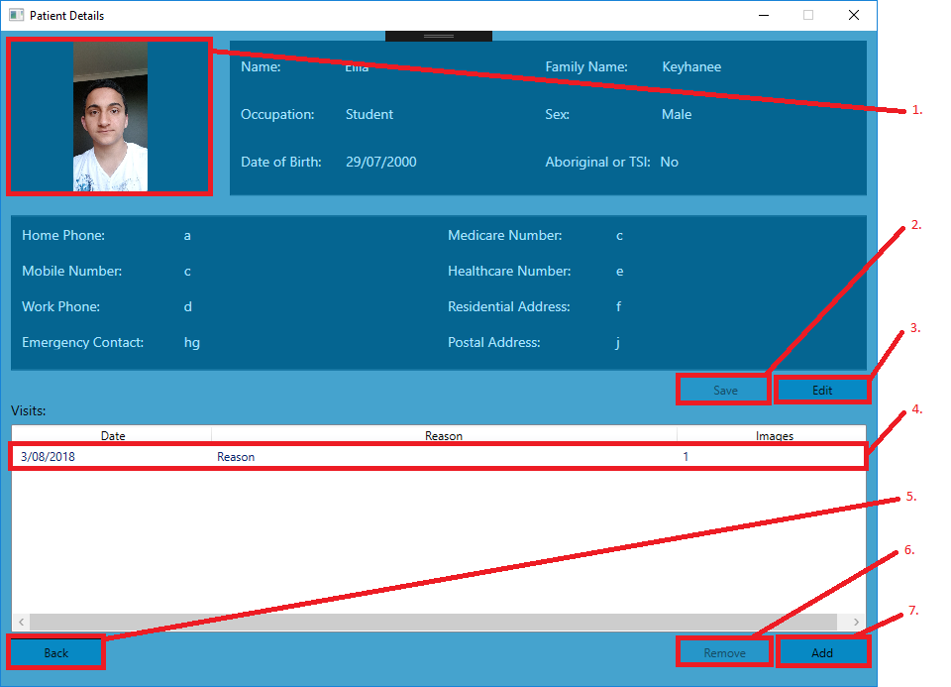

1. Profile Image: Click to add or change the profile image of the patient. Images can also be dragged into this field.
2. Save button: Saves changes made to Patient information. This button will remain disabled until edit is clicked.
3. Edit button: Makes the information fields editable and enables the save button.
4. Visit list item: Opens a visit in more detail. Displays the images and notes of the visit.
5. Back button: Returns to the patients list screen.
6. Remove button: Removes a selected visit. This button will remain disabled until a visit is selected.
7. Add button: Opens a visit screen where a new visit can be added.

## New Visit:

1. 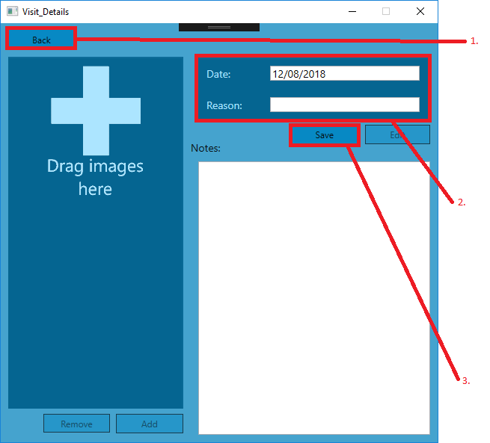Back button: Closes this window and erases any unsaved edits.
2. Visit Information: Enter the basic information of the visit.
3. Save button: Uploads visit information and effectively enters the Visit details screen. Please go to the Visit details screen for more information on the screen after Save is clicked.

## Visit Details Screen:

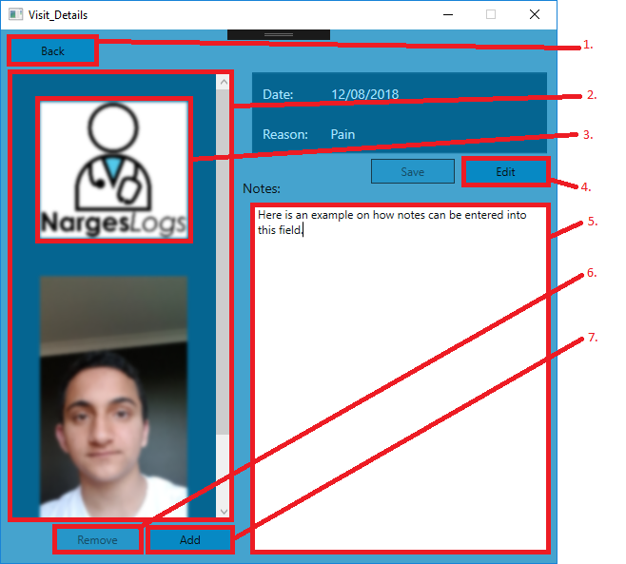

1. Back button: Closes the window and discards all unsaved changes.
2. Visit Images: Drag and Drop images into this field to add them to the visit or click the add button. When the number of visit images require more space, a scroll bar appears to allow the user to scroll through the images.
3. Visit image: Loads in with a blur effect until selected. The selected image is always clear while all other images remain blurry. Click on a selected image to save them to the local machine.
4. Edit button: changes the information fields to editable text boxes. The information can then be changed and saved via the Save button, which is enabled when edit is clicked.
5. Notes: Long notes can be entered this field. Notes are automatically saved when back is pressed.
6. Remove button: Removes the selected image. This field will remain disabled until an image is selected.
7. Add button: Click to add a new Visit Image.